Test Case: tc006_SPX_Dev5_Crear_Requisicion_Spot_Tipo_Cobro_Proyect_Urgent
Step 1 - Enter username and password and click to button Enter: Credentials Entered
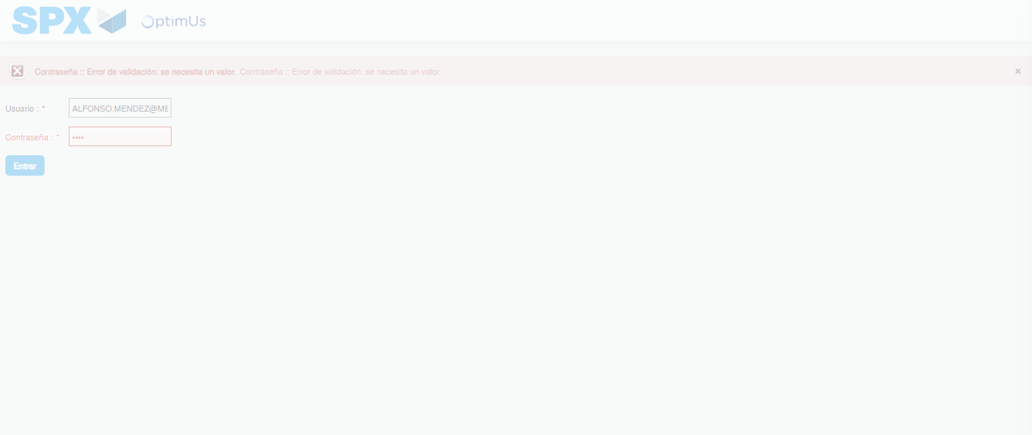Image file-name: QC_Testing-tc006_SPX_Dev5_Crear_Requisicion_Spot_Tipo_Cobro_Proyect_Urgent-1783373812384

Step 2 - Select to UEN and Access to Spot Buy Requisitions : UEN Correctly selected and Correct access
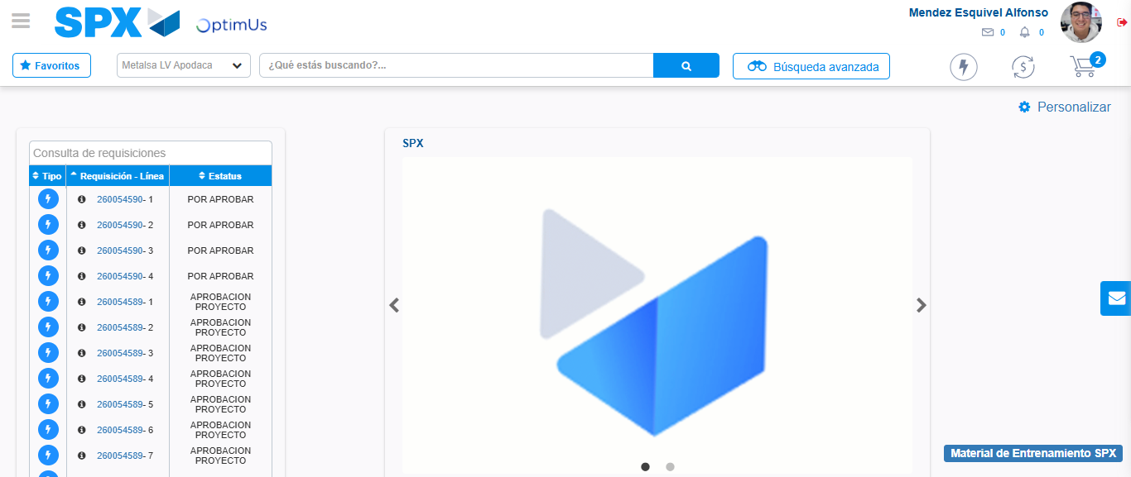Image file-name: QC_Testing-tc006_SPX_Dev5_Crear_Requisicion_Spot_Tipo_Cobro_Proyect_Urgent-1783373838002

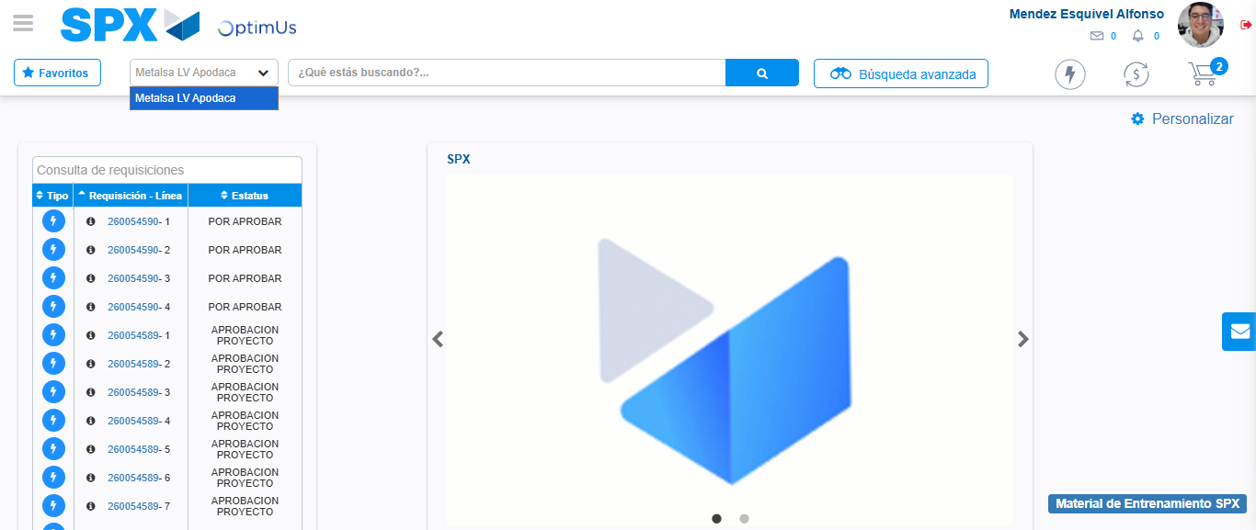Image file-name: QC_Testing-tc006_SPX_Dev5_Crear_Requisicion_Spot_Tipo_Cobro_Proyect_Urgent-1783373840531

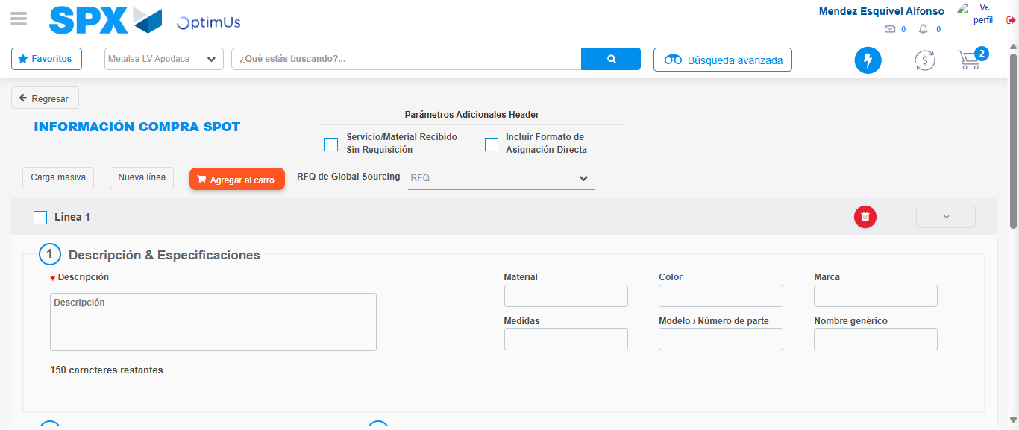Image file-name: QC_Testing-tc006_SPX_Dev5_Crear_Requisicion_Spot_Tipo_Cobro_Proyect_Urgent-1783373878622

Step 3 - Data Capture Spot Buy Requisition: Data captured correctly
Image file-name: QC_Testing-tc006_SPX_Dev5_Crear_Requisicion_Spot_Tipo_Cobro_Proyect_Urgent-1783373878865

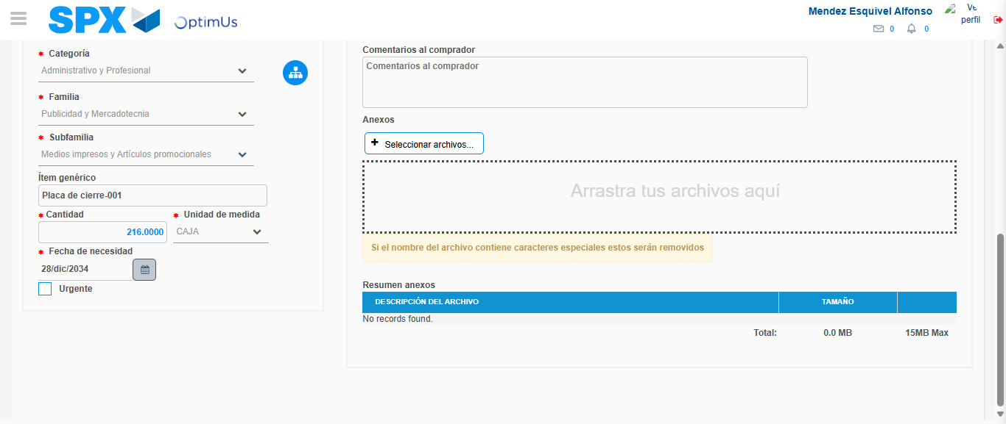Image file-name: QC_Testing-tc006_SPX_Dev5_Crear_Requisicion_Spot_Tipo_Cobro_Proyect_Urgent-1783373888653

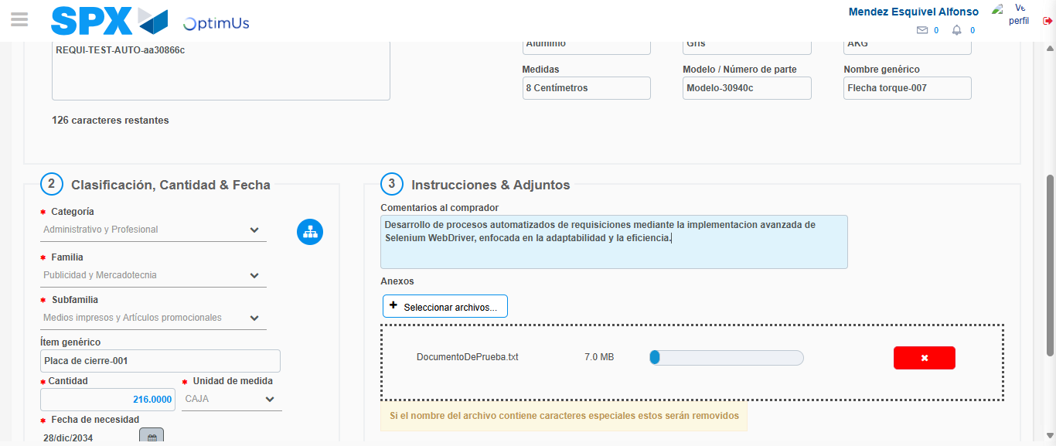Image file-name: QC_Testing-tc006_SPX_Dev5_Crear_Requisicion_Spot_Tipo_Cobro_Proyect_Urgent-1783373889403

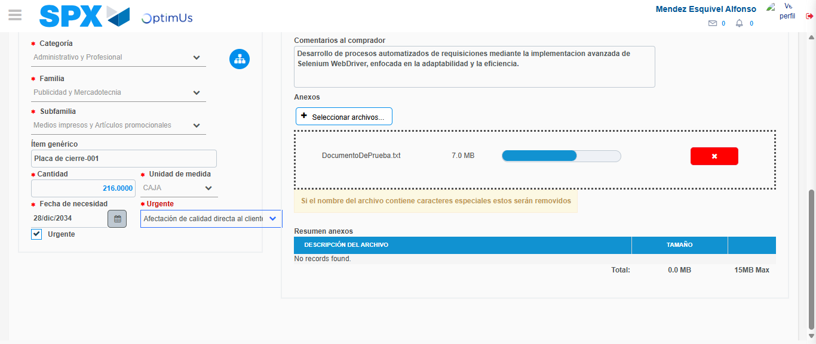Image file-name: QC_Testing-tc006_SPX_Dev5_Crear_Requisicion_Spot_Tipo_Cobro_Proyect_Urgent-1783373893101

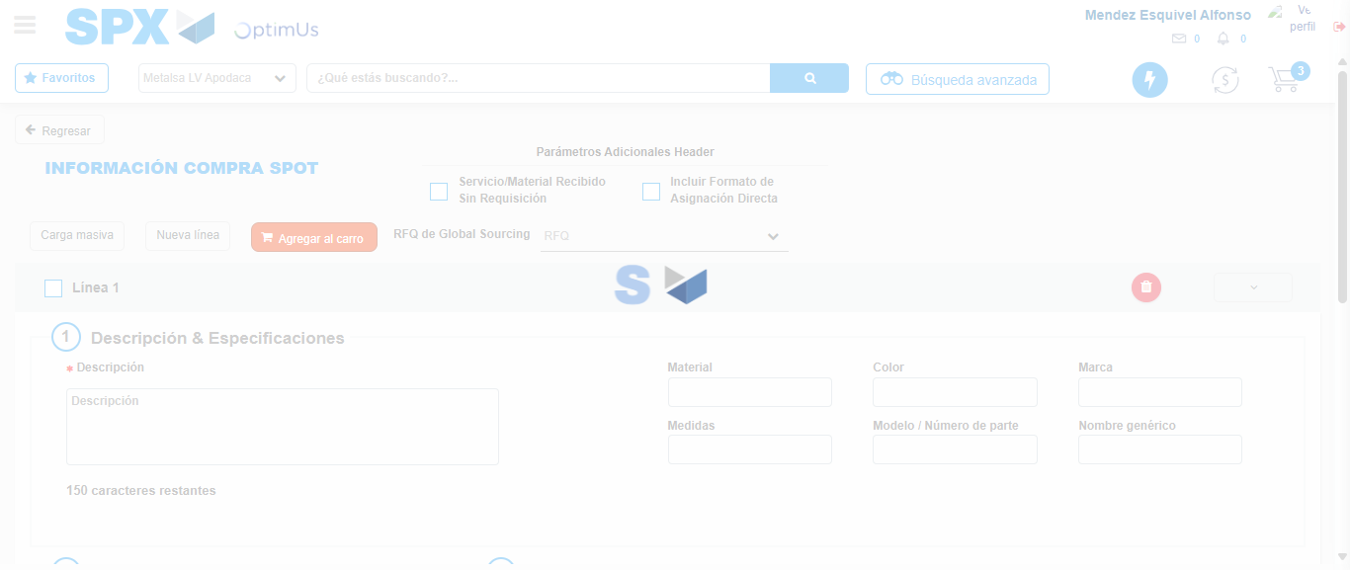Image file-name: QC_Testing-tc006_SPX_Dev5_Crear_Requisicion_Spot_Tipo_Cobro_Proyect_Urgent-1783373899481

Step 7 - Return to Main Page SPX : Return to Main Page SPX
Image file-name: QC_Testing-tc006_SPX_Dev5_Crear_Requisicion_Spot_Tipo_Cobro_Proyect_Urgent-1783373838002

Image file-name: QC_Testing-tc006_SPX_Dev5_Crear_Requisicion_Spot_Tipo_Cobro_Proyect_Urgent-1783373840531

Image file-name: QC_Testing-tc006_SPX_Dev5_Crear_Requisicion_Spot_Tipo_Cobro_Proyect_Urgent-1783373878622

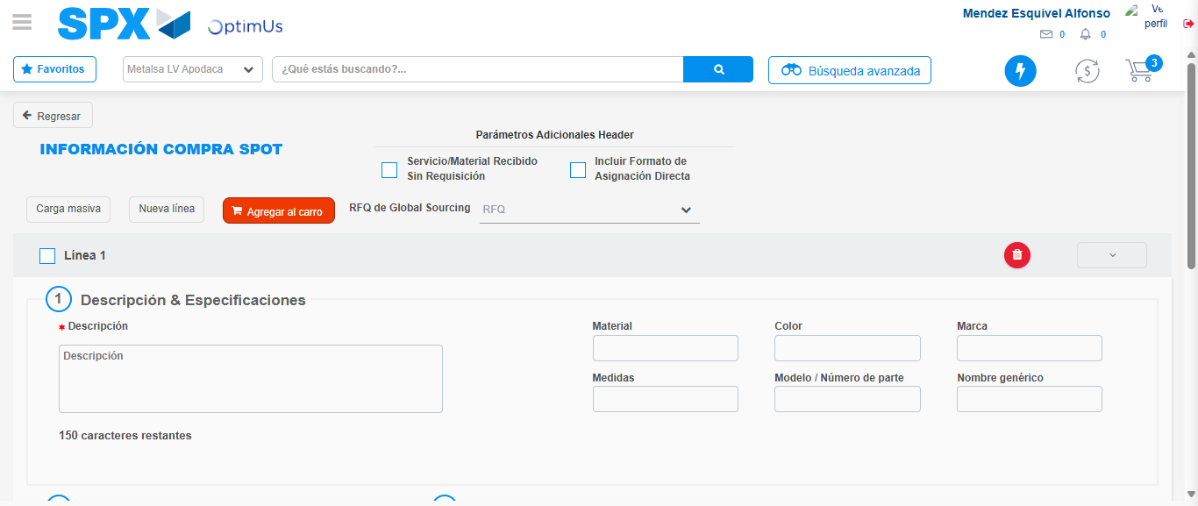Image file-name: QC_Testing-tc006_SPX_Dev5_Crear_Requisicion_Spot_Tipo_Cobro_Proyect_Urgent-1783373901698

Image file-name: QC_Testing-tc006_SPX_Dev5_Crear_Requisicion_Spot_Tipo_Cobro_Proyect_Urgent-1783373901879

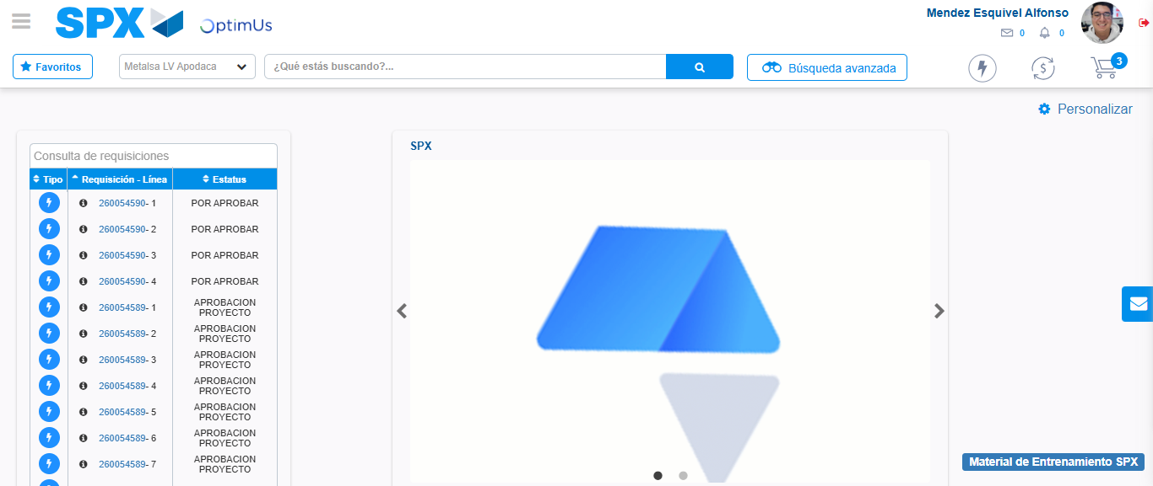Image file-name: QC_Testing-tc006_SPX_Dev5_Crear_Requisicion_Spot_Tipo_Cobro_Proyect_Urgent-1783373922946

Step 8 - Log Out : Log Out SPX
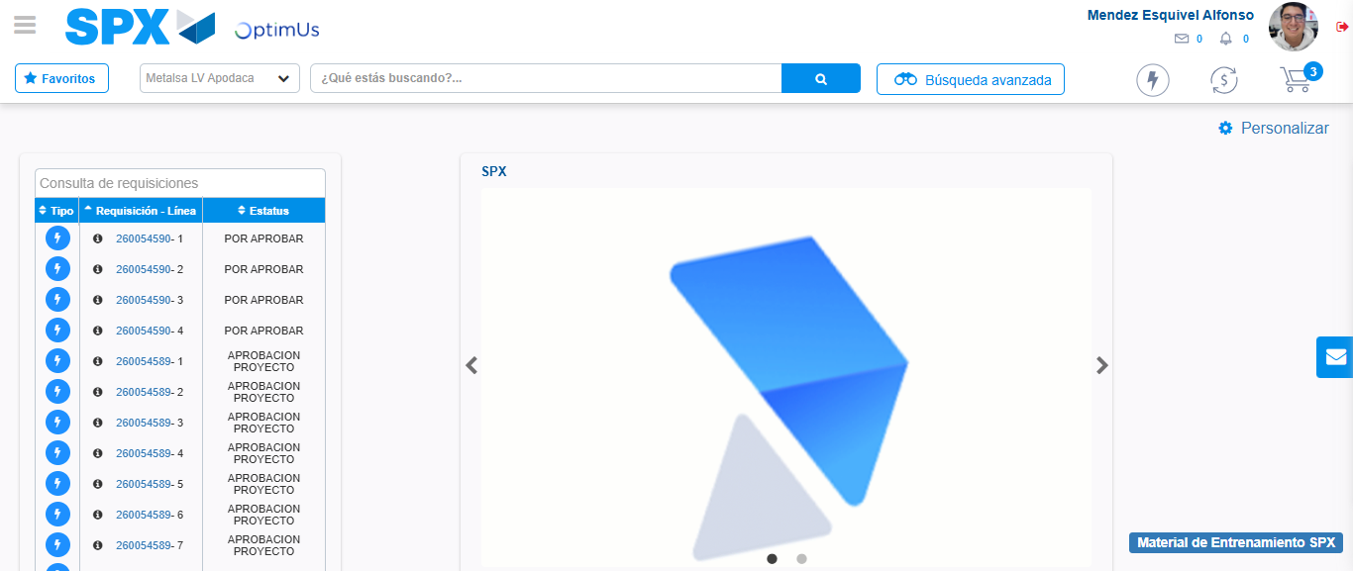Image file-name: QC_Testing-tc006_SPX_Dev5_Crear_Requisicion_Spot_Tipo_Cobro_Proyect_Urgent-1783373923155

